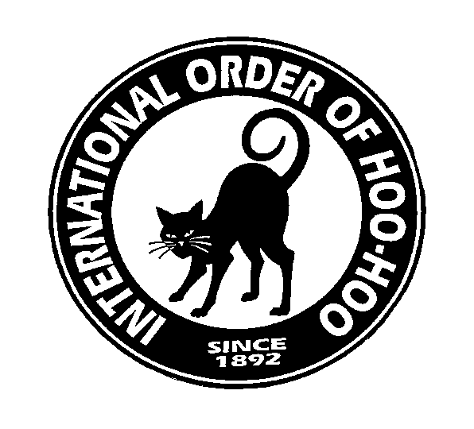
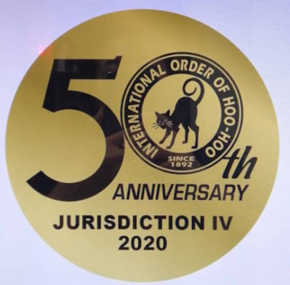

Nine Lives

Newsletter of Jurisdiction IV

MARCH 2023

Through Hoo-Hoo a United Forest Products Industry

As advised in the February Nine Lives the JIV board has put together an agenda for the CONVENTION AND AGM.

We welcome your feedback of who would be willing to attend a weekend AGM and gathering as follows.

Location: Ballarat, Victoria
Date : 26th – 28th May 2023
Mercure Hotel and Convention Centre

Black Cats will be free 2023

Black Cat Friday: Board meeting/Ice breaker Cocktail Party 5.29 – 9.00pm
Saturday: 9am – 12 Noon AGM and election of Officers if any
Saturday: Noon – 1.09pm Excursion (relevant to the Destination)
Saturday: 6.59pm Dinner (JIV President short address, and Awards)
Sunday: Farewell Breakfast

Registration fee $229.00pp

Of course, you could come earlier or stay later,

Would you be prepared to attend this AGM/Convention?

Yes No

Do you have any suggestions/questions?

Name: Member No Club:

Please return this request to: jivsecretary@iinet.net.au by the 31st March

Fraternal, Helpful, Grateful, Friendly, Tolerant, Progressive, Industrious, Ethical and Loyal

